SOLE TO SOUL ARTWORK LIST
7 June 2025
SMO Contemporary Art is proud to present a curated selection of 32 available works from Sole to Soul, the long-anticipated solo exhibition of master sculptor Kenny Adewuyi. This retrospective spans over three decades of artistic practice, offering a rare and intimate insight into his evolving language of bronze sculpture and drawing. From deeply expressive sketches to monumental, life-size sculptures, each piece reflects Adewuyi’s lifelong dialogue with humanity’s emotional and physical journeys.

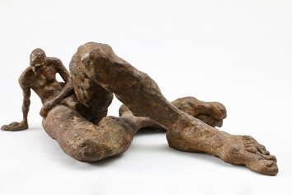 | Kenny Adewuyi  But Why, 2022  Bronze  20 x 24 x 51 cm
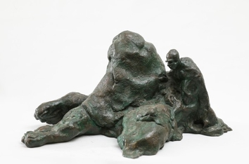 | Kenny Adewuyi  It Takes Time, 2004  Bronze  25 x 24 x 49 cm
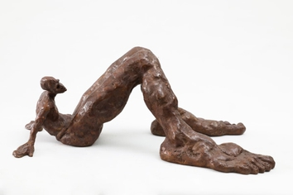 | Kenny Adewuyi  In Desolution, 2011  Bronze  16 x 23 x 35
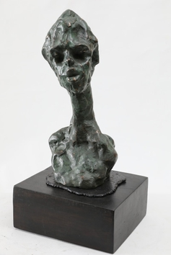 | Kenny Adewuyi  Innocent Boy, 2019  Bronze  28 x 13 x 13 cm
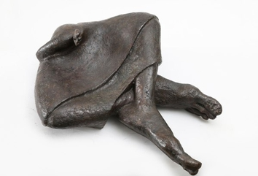 | Kenny Adewuyi  Sitting In Limbo, 2009  Bronze  16 x 34 x 45 cm
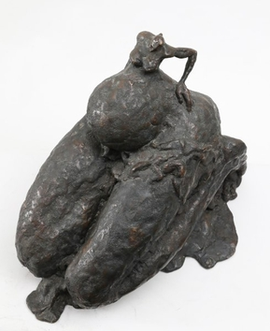 | Kenny Adewuyi  Come To My Aid, 2002  Bronze  34 x 26 x 51 cm
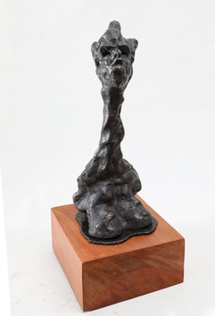 | Kenny Adewuyi  In Dire Situation, 2019  Bronze  32 x 13 x 18 cm
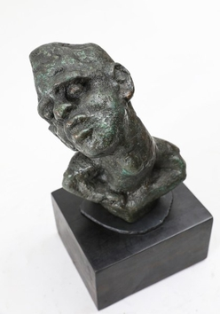 | Kenny Adewuyi  Can't Cheat Nature, 2008  Bronze  21 x 6 x 7.5 cm
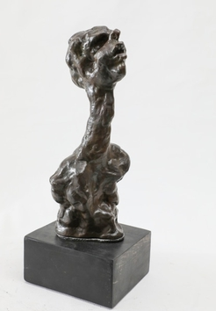 | Kenny Adewuyi  Man In Captivity, 2019  Bronze  29 x 12 x 12 cm
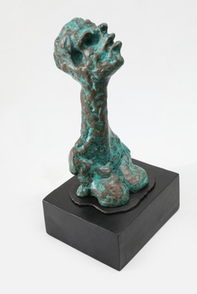 | Kenny Adewuyi  Woman in Captivity, 2019  Bronze  29 x 13 x 14 cm
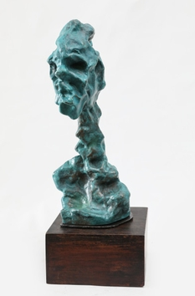 | Kenny Adewuyi  The Old, 2019  Bronze  31 x 13 x 13 cm
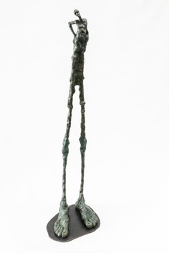 | Kenny Adewuyi  Cant Stand The Pain, 2022  Bronze  71 x 15 x 20 cm
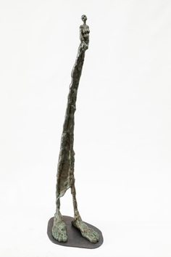 | Kenny Adewuyi  Have Mercy, 2022  Bronze  73 x 16 x 19 cm
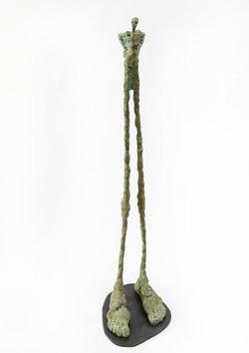 | Kenny Adewuyi  Lively Up Yourself, 2022  Bronze  71 x 15 x 20 cm
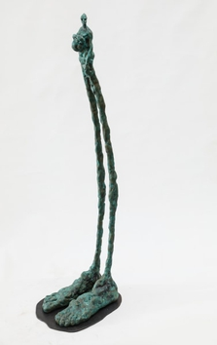 | Kenny Adewuyi  It Has Happened, 2022  Bronze  72 x 14 x 19 cm
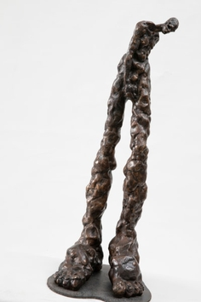 | Kenny Adewuyi  It Is Hard Way To Go, 2009  Bronze  57 x 19 x 20 cm
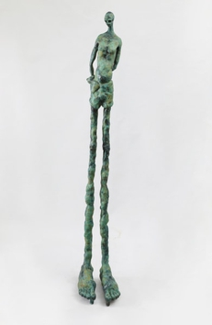 | Kenny Adewuyi  Poor Boy, 2024  Bronze  145 x 22 x 26 cm
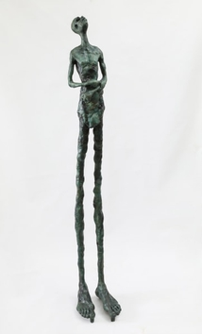 | Kenny Adewuyi  I Just Wonder, 2024  Bronze  147 x 23 x 30 cm
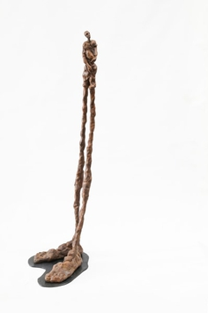 | Kenny Adewuyi  In Plight For Safety, 2022  Bronze  73 x 16 x 21 cm
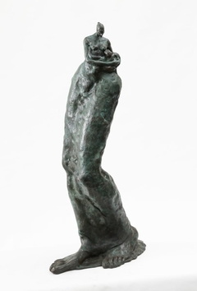 | Kenny Adewuyi  My Child, 2007  Bronze  74 x 21 x 23 cm
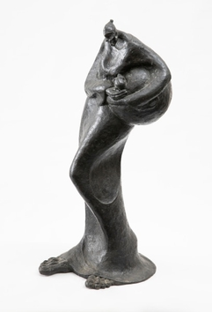 | Kenny Adewuyi  Affection, 1993  Bronze  65 x 24 x 31 cm
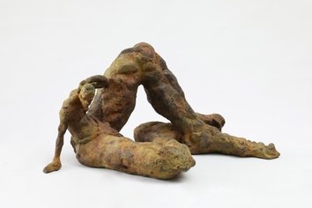 | Kenny Adewuyi  Take Courage, 2002  Bronze  23 x 28 x 46 cm
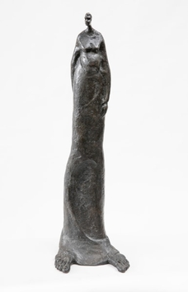 | Kenny Adewuyi  Your Guess Could Be As Mine, 2008  Bronze  75 x 14 x 23 cm
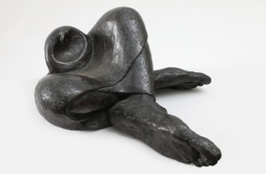 | Kenny Adewuyi  Lady in Deep Thought, 2007  Bronze  17 x 25 x 44 cm
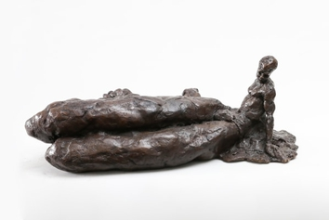 | Kenny Adewuyi  Too Hard To Bear, 2002  Bronze  16 x 41 x 50 cm
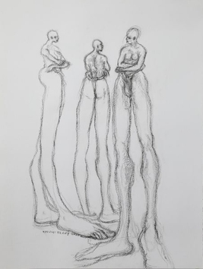 | Kenny Adewuyi  In Contemplation, 2024  Black Conte Charchoal  65 x 49 cm
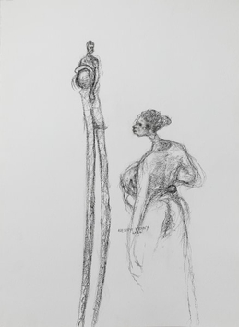 | Kenny Adewuyi  It Has Happened, 2024  Black Conte Charchoal  65 x 49 cm
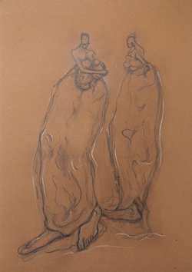 | Kenny Adewuyi  My Child, 2024  Black Conte Charchoal  65 x 50 cm
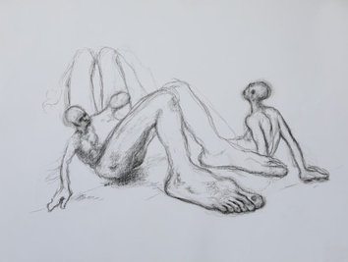 | Kenny Adewuyi  In Desolution, 2024  Black Conte Charchoal  65 x 50 cm
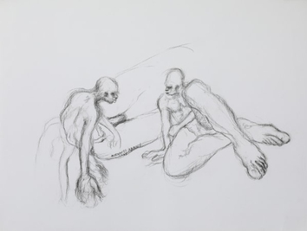 | Kenny Adewuyi  But Why?, 2024  Black Conte Charchoal  65 x 50 cm
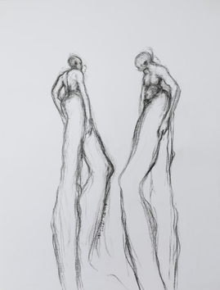 | Kenny Adewuyi  It's Hard Way To Go, 2024  Black Conte Charchoal  65 X 50 cm
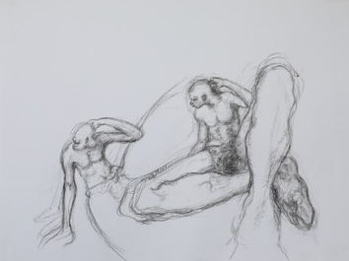 | Kenny Adewuyi  Take Courage, 2024  Black Conte Charchoal  65 x 50 cm
Adewuyi’s signature elongated forms and exaggerated feet often the most dominant part of his figures invite us to reflect on our own life paths. With every curve, texture, and contour, his work reminds us of the stories etched in our soles.
Explore and collect from this profound body of work.

